Survey123: Image map preparation

Contents

Overview 1

SVG contents 1

Use Inkscape to create new path(s) in the SVG file 2

Survey123 Connect Tasks 7

# Overview

1. SVG = Scalable Vector Graphic
2. An .SVG file is the only file type that can be used in Survey123 as an image map
3. Will need to edit the .SVG file to create selectable “paths” via a graphic software editor like Inkscape
   1. <https://inkscape.org/>
   2. At the time this doc was created, current version
      1. Inkscape 0.92.4 (5da689c313, 2019-01-14)

# SVG contents

1. Open your SVG in a text editor
2. XML file format
   1. Path Elements
      1. Id 🡪 unique identifier
      2. D 🡪 coordinates of the selectable area
      3. Style 🡪 how the path is displayed
3. Any Path element with an ID attribute will be selectable in Survey123
   1. Don’t want an ID value for the entire image. If you don’t delete the ID tag, the entire image will be selectable.

# Use Inkscape to create new path(s) in the SVG file

1. Open the SVG file in Inkscape

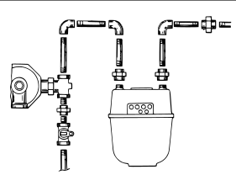

1. Edit 🡪 XML Editor (Shift + Ctrl + X)
   1. Any element with a <svg:Path ID = “something”> value will be selectable in Survey123.
   2. If you click on “Path5”, the entire image is selected.
      1. Note: Your image may not have a Path ID set and step 2C and 2D can be skipped

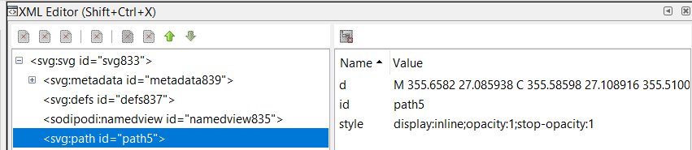

* 1. To prevent the full image from being selectable, delete the ID attribute.
  2. Highlight the ID field then click the Delete attribute button

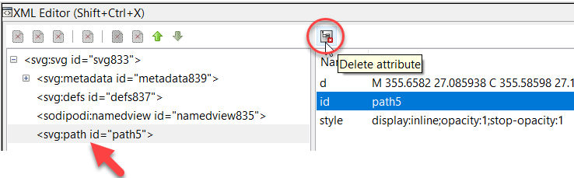

1. Create the selectable polygon
   1. Click the icon “Draw Bezier Curves and straight lines” and then create a polygon

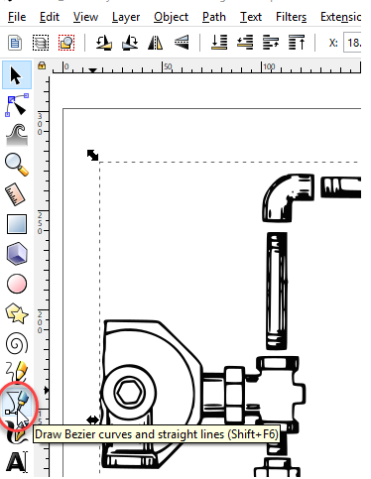

* 1. In the XML editor, notice how a new <SVG:Path ID> tag was created

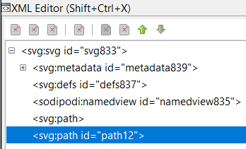

* 1. Select the new tag
  2. At the bottom of Inkscape, there is a color palette. Pick a different color to see how well your polygon looks

|  |  |
| --- | --- |
|  |  |

* 1. If needed, use the “select and transform objects” button to reshape the polygon



* 1. Once happy with polygon, change color back to none

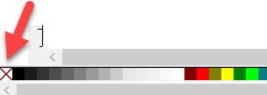

* 1. In the XML Editor, change the Path ID of the polygon to something meaningful
     1. The exact spelling will be needed in Survey123

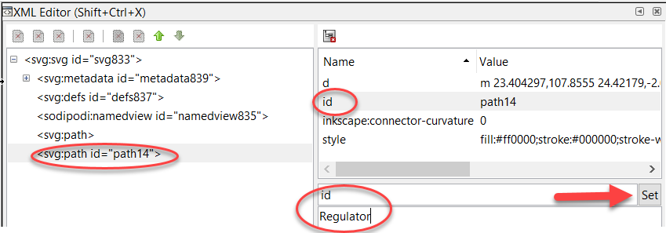

* + 1. Click the Set button and the Path id value will be changed

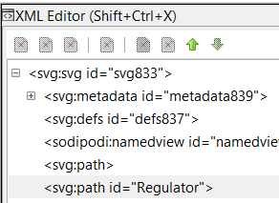

1. File 🡪 Save As
   1. Change “save as type” to Plain SVG (*.svg)

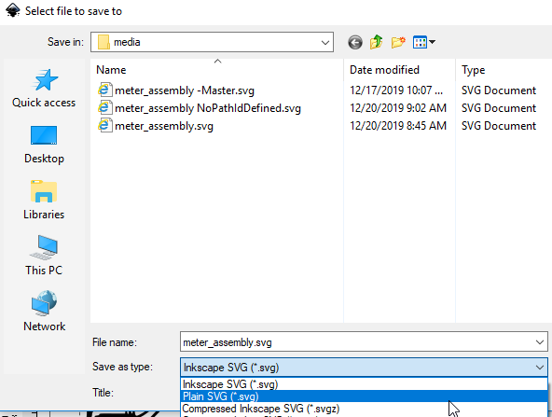

1. Repeat steps 1-6 for as many selectable areas as needed.

# Survey123 Connect Tasks

1. Screenshot

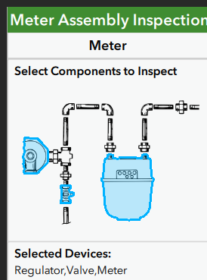

1. Survey Design
   1. Start Survery123 connect
   2. The SVG file must reside in the media folder of the survey
   3. Click on the Files icon for your project.
   4. Windows Explorer will open
   5. Double click on the media folder and copy your SVG file here
2. Choices Tab
   1. Create list entries with the IDs entered in the SVG file.
      1. List_name: Can be any meaningful text
      2. Name: MUST match the Path ID value in the SVG file
      3. Label: I typically use the same Name value

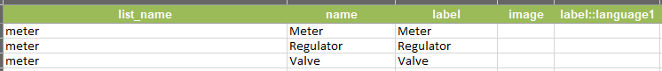

1. Survey Tab
   1. Create a “Select Multiple” type using the List name from the previous step

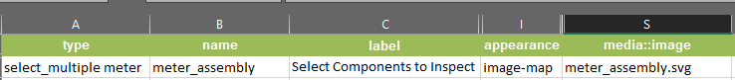

* + 1. Type: select_multiple <list_name>
    2. Appearance: image-map
    3. Media::image: <image name>.svg
  1. Create a note type to show the selected components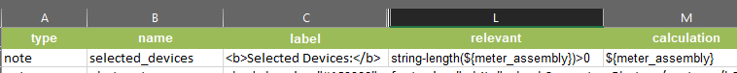
     1. Type: note
     2. Relevant: string-length(${meter_assembly})>0
     3. Calculation: ${meter_assembly}
  2. Based on selected component of the image, you’ll want to show certain elements

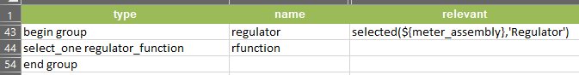

* + 1. Relevant: selected(${meter_assembly},'Regulator')
       1. Repeat this step for each selectable component in the image
  1. Screenshots

|  |  |
| --- | --- |
|  |  |